SUPPLEMENTARY INFORMATION

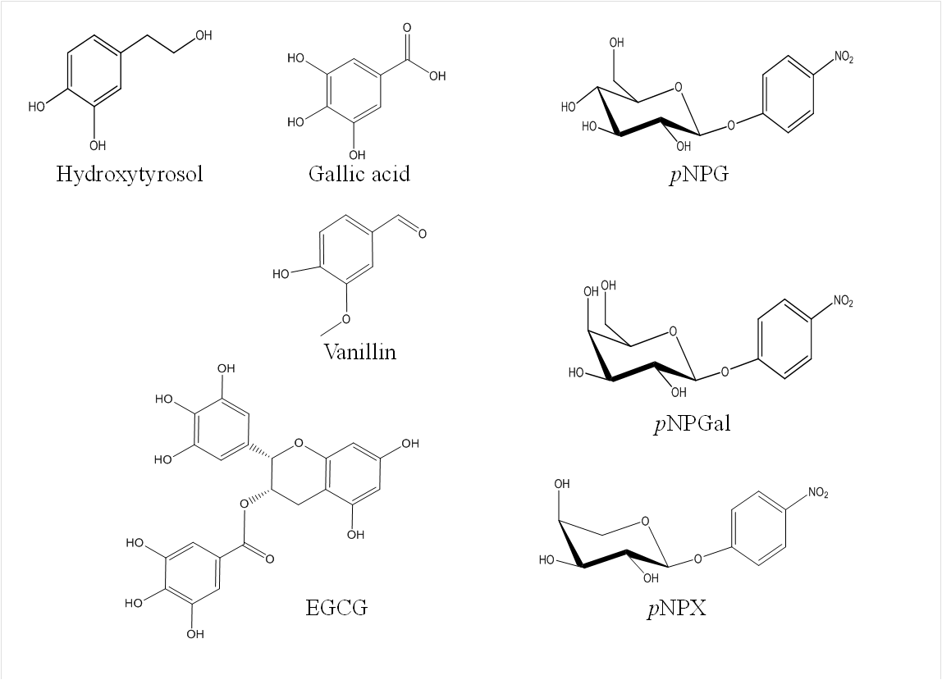
Glycoside |  | Intensity | m/z
EGCG-glucose |  | 533662 | 643.2
Vanillin-glucose |  | 43977 | 337.1
Hydroxytyrosol- glucose |  | 22386 | 339.1
Gallic acid-glucose |  | 48294 | 355.1
pNPX-glucose |  | 307637 | 456.1
pNPGal-glucose |  | 569165 | 486.1
pNPG-glucose |  | 430001 | 486.2
G2 |  | 449035 | 365.1
G3 |  | 428105 | 527.2
G4 |  | 287540 | 689.3
G5 |  | 59761 | 851.3

Figure S1. Top: Molecular structure of the acceptors selected for transglycosylation catalysed by the glucosynthase BGL-1-E521G. Bottom: ESI-MS data glycosides obtained by transglycosylation catalyzed by BGL-1-E521G. All the glycosides were detected as Na⁺ adducts.

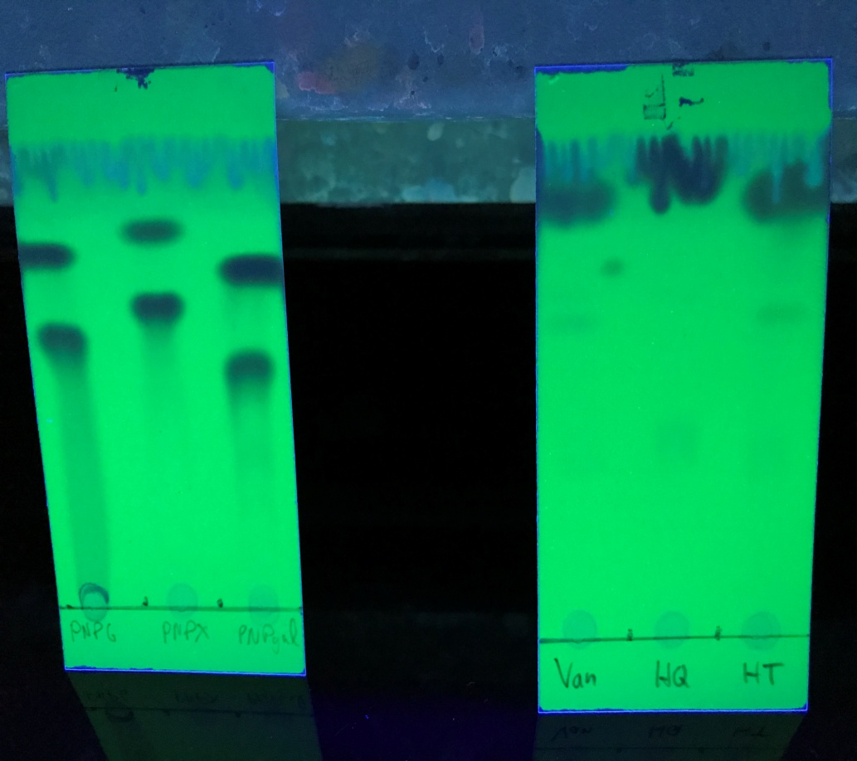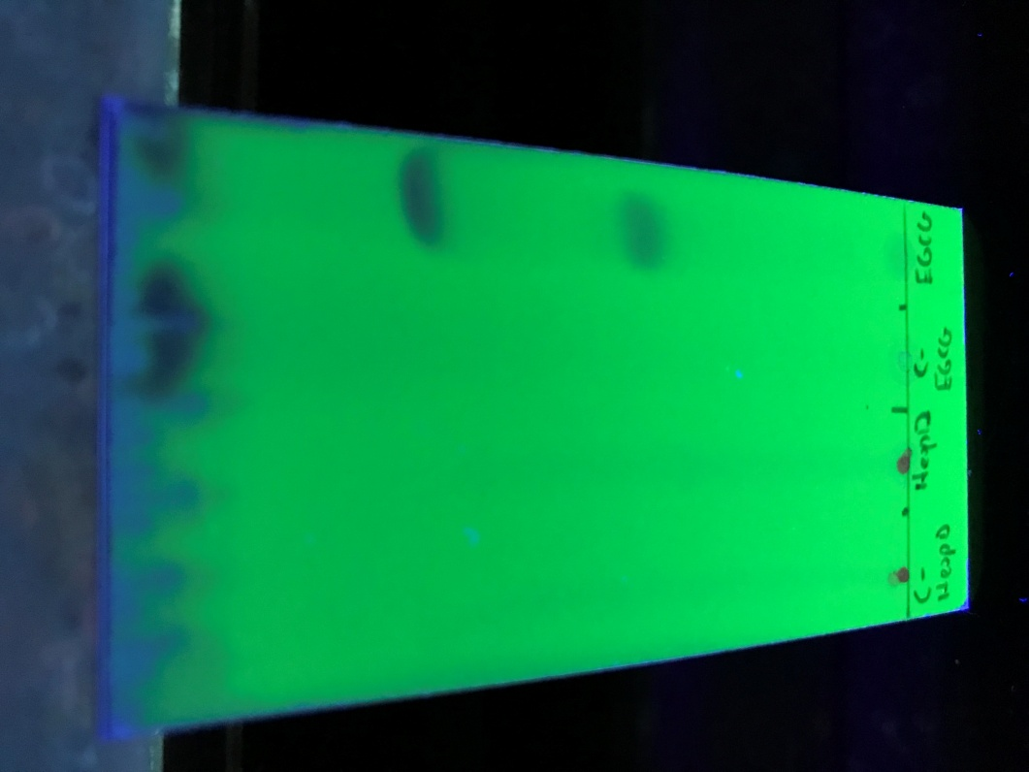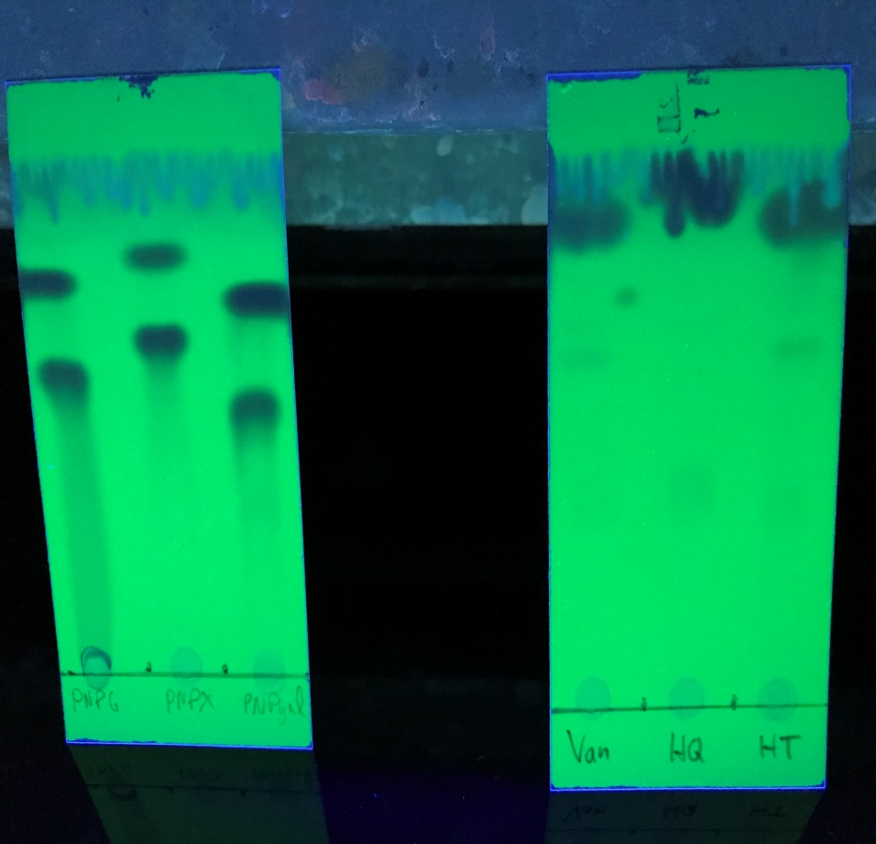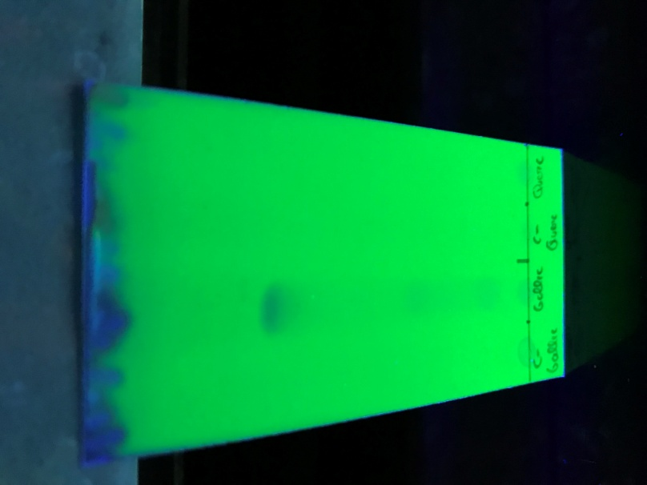
B
D
C
A

Figure S2. Thin layer chromatography of the different reaction mixtures in transglycosylation reactions using BGL-1-E521G. A) Gallic acid reaction. B) Nitrophenyl sugars reaction. C) Vanillin, hydroquinone and hydroxytyrosol reactions. D) EGCG reaction. The new products detected are signaled with arrows.

BG1 QEVYITTTGYTARPQCTEPPATPTFRFQSFSYASLNDTIRYAISVPSPTTTHTYGPAYTD 60
Termite ------------------------------------------------------------ 0
Clostridium ------------------------------------------------------------ 0
Trichoderma ------------------------------------------------------------ 0

BG1 AVAKLSTKLTTTTWGSWVPSQTVISATDTADKYGQAAWSSQWLHASLANYTNIGLYTTTV 120
Termite ------------------------------------------------------------ 0
Clostridium ------------------------------------------------------------ 0
Trichoderma ------------------------------------------------------------ 0

BG1 NPTPLPSSELVLPPRDYFGPTDCYNFPEGFTFGVAGSAAQIEGAIGLEGRAPSILEKLLP 180
Termite --------------MDVASSDTVYTFPDEFKLGAATASYQIEGAWDENGKGPNIWDTLTH 46
Clostridium --------------------MEKLRFPKDFIFGTATAAYQIEGAYKEDEKGESIWDRFSH 40
Trichoderma -----------------MHHHHHHMLPKDFQWGFATAAYQIEGAVDQDGRGPSIWDTFCA 43
:*. * * * :: ***** : :. .* : :

BG1 DT------EPQDYVTNENYYLYKQDIQRLASXGVKYYSFSISWGRILPFTVPGSPINEQG 234
Termite EHPDYVVDGATGDIADDSYHLYKEDVKILKELGAQVYRFSISWARVLPEGH-DNIVNQDG 105
Clostridium -IPGNVAKMHNGDIACDHYHRYKEDVQLLKSLGIKSYRFSIAWPRIFPKGF--GEINQKG 97
Trichoderma -QPGKIADGSSGVTACDSYNRTAEDIALLKSLGAKSYRFSISWSRIIPEGGRGDAVNQAG 102
. : : * :*: * . * : * ***:* *::* . :*: *

BG1 LKHYNDLIDYVLEVGMVPIVTMLHFDTPLYFINASAGYVVPDIGYQNGGYWNK-EFVDSF 293
Termite IDYYNNLINELLANGIEPMVTMYHWDLPQALQDL-------------GGWPNL-VLAKYS 151
Clostridium IQFYRDLIDELIKNDIEPAITIYHWDLPQKLQDI-------------GGWANP-QVADYY 143
Trichoderma IDHYVKFVDDLLDAGITPFITLFHWDLPEGLHQR------------YGGLLNRTEFPLDF 150
:..* .::: :: .: * :*: *:* * : : ** * .

BG1 VNYGKILFTHFADRVPFWVTINEPLLYAFN----------------------FTGLDNVV 331
Termite ENYARVLFKNFGDRVKLWLTFNEPLTFMDGYASEIGMAPSINTPGIGD----YLAAHTVI 207
Clostridium VDYANLLFREFGDRVKTWITHNEPWVAS-----YLGYALGVHAPGIKDMKMALLAAHNIL 198
Trichoderma ENYARVMFRAL-PKVRNWITFNEPLCSA-----IPGYGSGTFAPGRQSTSEPWTVGHNIL 204
:*..::* : :* *:* *** ..::

BG1 HAHAELYHFYHDT---LNGTGKVGLKLNDNFGVPKHPENQTEIDAANRFNDMQLGVFAYP 388
Termite HAHARIYHLYDQEFR-AEQGGKVGISLNINWCEPATN-SAEDRASCENYQQFNLGLYAHP 265
Clostridium LSHFKAVKAYRE----LEQDGQIGITLNLSTCYSNS-ADEEDIAAAHRSDGWNNRWFLDA 253
Trichoderma VAHGRAVKAYRDDFKPASGDGQIGIVLNGDFTYPWDAADPADKEAAERRLEFFTAWFADP 264
:* . : * : . *::*: ** . . : :... :

BG1 ICL-GQQYPKSILDTLPG-----------AKPLSKKELEYISHTTDFIGIDAYTATVISV 436
Termite IFTEEGDYPAVLKDRVSRNSADEGYTDSRLPQFTAEEVEYIRGTHDFLGINFYTALLGKS 325
Clostridium AL--KGTYPEDMIKIFSD--------TNIMPELPKELFTEVFETSDFLGINYYTRQVVKN 303
Trichoderma IY--LGDYPASMRKQLGD--------R--LPTFTPEERALVHGSNDFYGMNHYTSNYIRH 312
** : . . : : : : ** *:: **

BG1 PAEGIEYCSKQ---NMTTNSLYPYCVTQETVNSYGWDIGYRSQSYVYITPTYLRAFLSYI 493
Termite GVEGYEPSRYR-DSGVILTQ---DA----------WP--ISASSWLKVVPWGFRKELNWI 370
Clostridium NSEAFIGA-----ESV-------AMD---------NP--KTEMGWE-IYPQGLYDLLTRI 339
Trichoderma RSSPASADDTVGNVDVLFTNKQGNCI---------GP--ETQSPWLRPCAAGFRDFLVWI 361
. .: : : * *

BG1 WNTYKT-PLVLSEFGFPVYAESTRDLVDQLYDSPRSQYYLSFMSELLKSIWEDGVDVIGA 552
Termite KNEYNNPPVFITENGFSDY--------GGLNDTGRVHYYTEHLKEMLKAIHEDGVNVIGY 422
Clostridium HRDYGNIDLYITENGAAFNDMVN--RDGKVEDENRLDYLYTHFAAALSIEAGVPLKGY 396
Trichoderma SKRYGYPPIYVTENGTSIKGESDLPKEKILEDDFRVKYYNEYIRAMVTAVELDGVNVKGY 421
. * : ::* * : * * .* .: :.: ** : *

BG1 IAWSFMDNWEFG-DYAQQFGMQVVNRTTQE-RWFKK-SFFDIVDFVGARNGLGYAAASFL 609
Termite TAWSLMDNFEWLRGYSEKFGIYAVDFEDPARPRIPKESAKVLAEIMNTRKIPERFRDLEH 482
Clostridium YIWSFMDNFEWAEGYEKRFGIVHVNYKTQE-RTIKK-SAYWYKELIERSNKLEHHHHHH- 453
Trichoderma FAWSLMDNFEWADGYVTRFGVTYVDYENGQ-KRFPKKSAKSLKPLFD------------- 467
**:***:*: .* :**: *: : * * :.

BG1 EQKLISEEDLNSAVD------ 630
Termite HHHHH---------------- 487
Clostridium --------------------- 453
Trichoderma --------------------- 467

Figure S3. Alignment of BGL-1 amino acid sequence with the BGLs sequences of bacterium Clostridium cellulovorans, fungus Trichoderma reesei and termite Neotermes koshunensis. The catalytic amino acids are highlighted in red.

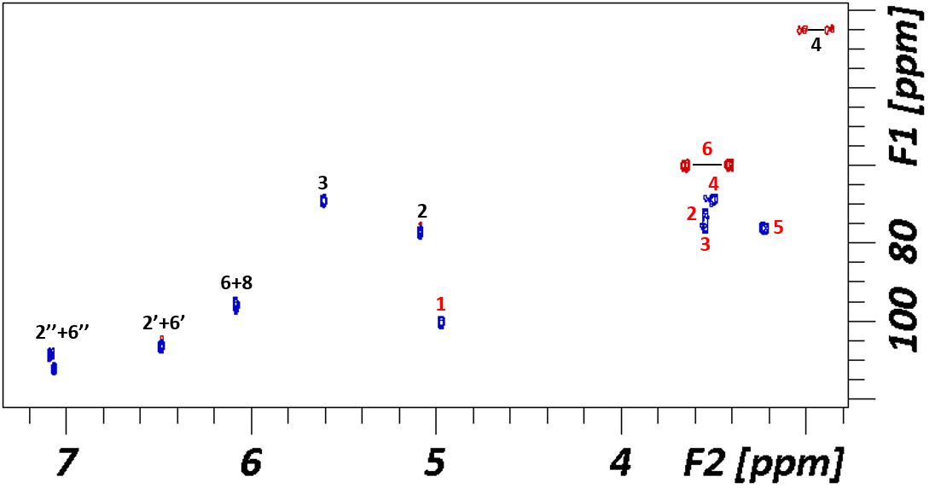
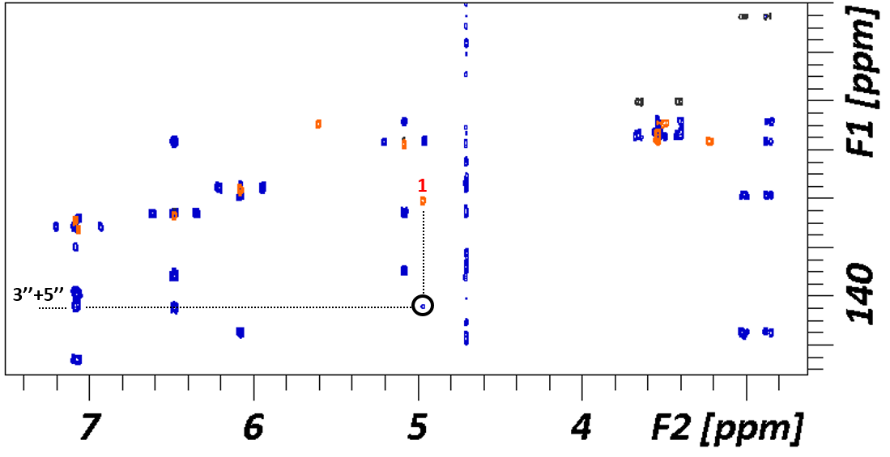
Figure S4. NMR Spectra of the EGCG glycoside. Top: Labelled ¹H-¹³C HSQC of EGCG-glucose. Bottom: Superimposition of ¹H-¹³C HSQC (black/orange) and HMBC (blue) spectra. The correlation of the anomeric position is highlighted.
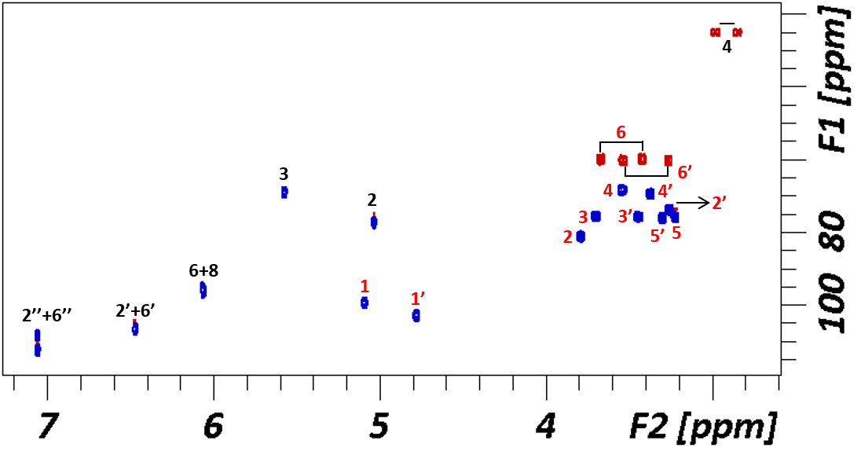
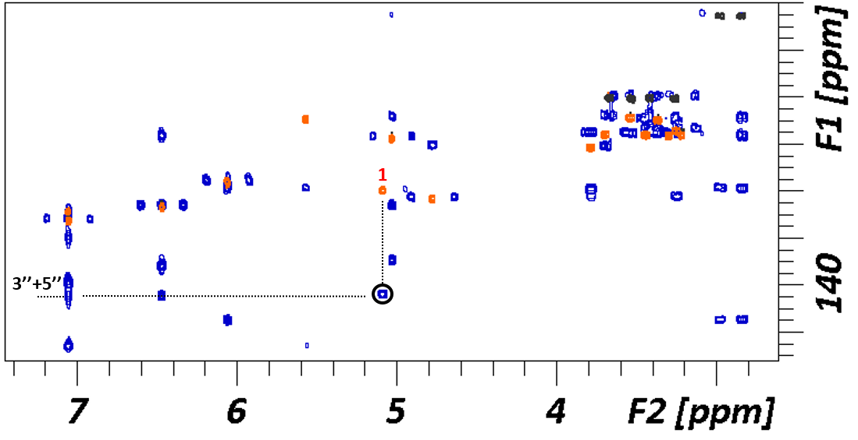
Figure S5. NMR Spectra of the EGCG diglycoside. Top: Labelled ¹H-¹³C HSQC of EGCG-sophorose. Bottom: Superimposition of ¹H-¹³C HSQC (black/orange) and HMBC (blue) spectra. The correlation of the anomeric position is highlighted.

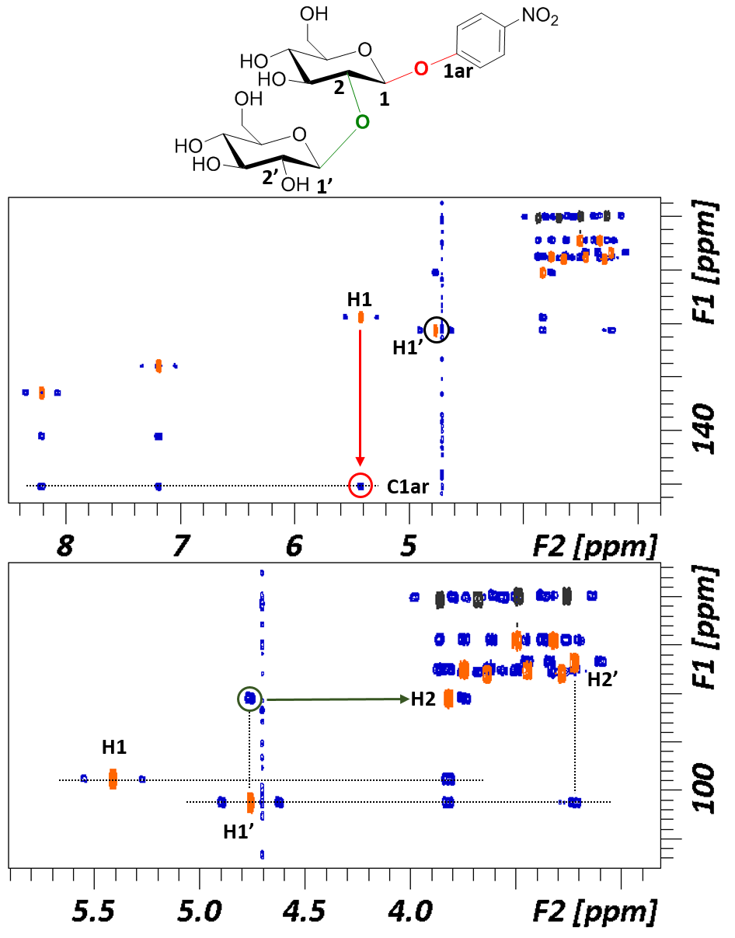
A
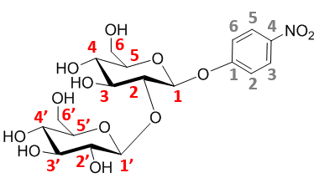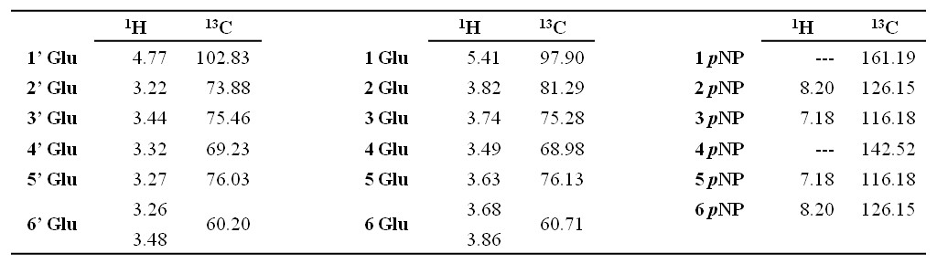
B

Figure S6. A) Top: structure of the Glucose-Glucose-pNP derivative. Superimposition of ¹H-¹³C HSQC (orange/black) and HMBC (blue). Bottom: Expansion of the carbohydrate region. Arrows represent the key cross peaks for the characterization of the molecule. The lower panel shows the correlation of the anomeric H1’ proton of the transferred glucose with the carbon at position 2 in the acceptor glucose for the disaccharide linkage (green), and the upper panel displays the correlation of the anomeric position of the acceptor glucose and the quaternary carbon of the pNP ring residue (red). B) Structure, deduced from NMR analysis, of the pNPG-glucoside produced by transglycosylation of pNPG with the synthase BGL-1-E521G. Every C atom in the molecules is numbered to clarify the identification of the signals. Chemical shifts (ppm) are indicated in the table.

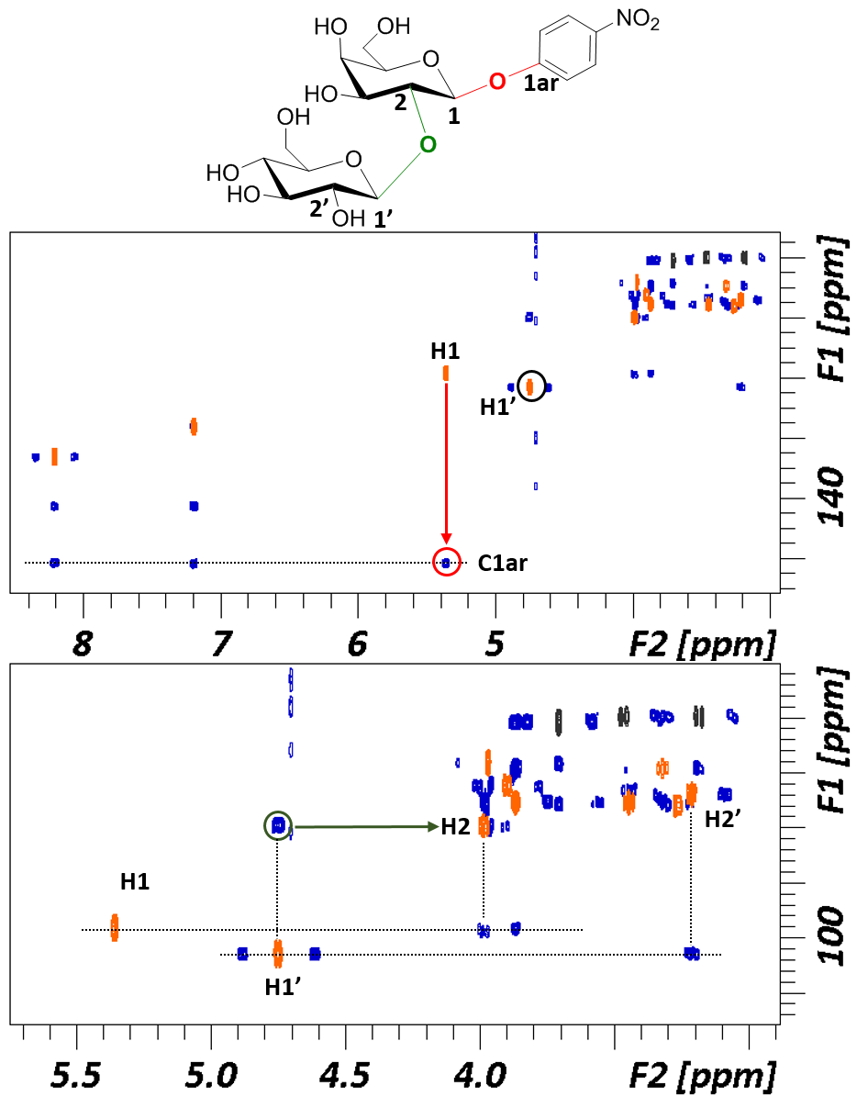
A

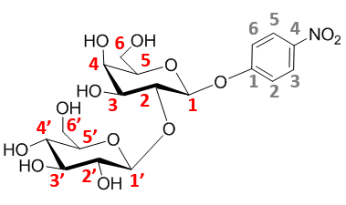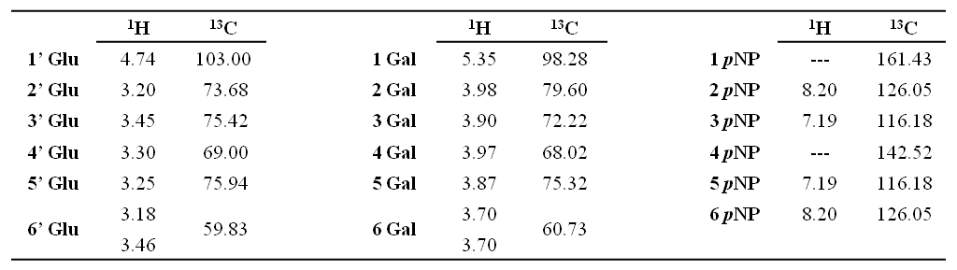

Figure S7. A) Top: structure of the Glucose-Galactose-pNP derivative. Superimposition of ¹H-¹³C HSQC (orange/black) and HMBC (blue). Bottom: Expansion of the carbohydrate region. Arrows represent the key cross peaks for the characterization of the molecule. The lower panel shows the correlation of the anomeric H1’ proton of the transferred glucose with the carbon at position 2 in the acceptor galactose for the disaccharide linkage (green), and the upper panel displays the correlation of the anomeric position of the acceptor galactose and the quaternary carbon of the pNP ring residue (red). B) Structure, deduced from NMR analysis, of the pNPGal-glucose product obtained by transglycosylation of pNPGal with the synthase BGL-1-E521G. Every C atom in the molecule is numbered to clarify the identification of the signals. Chemical shifts (ppm) are indicated in the table.
B

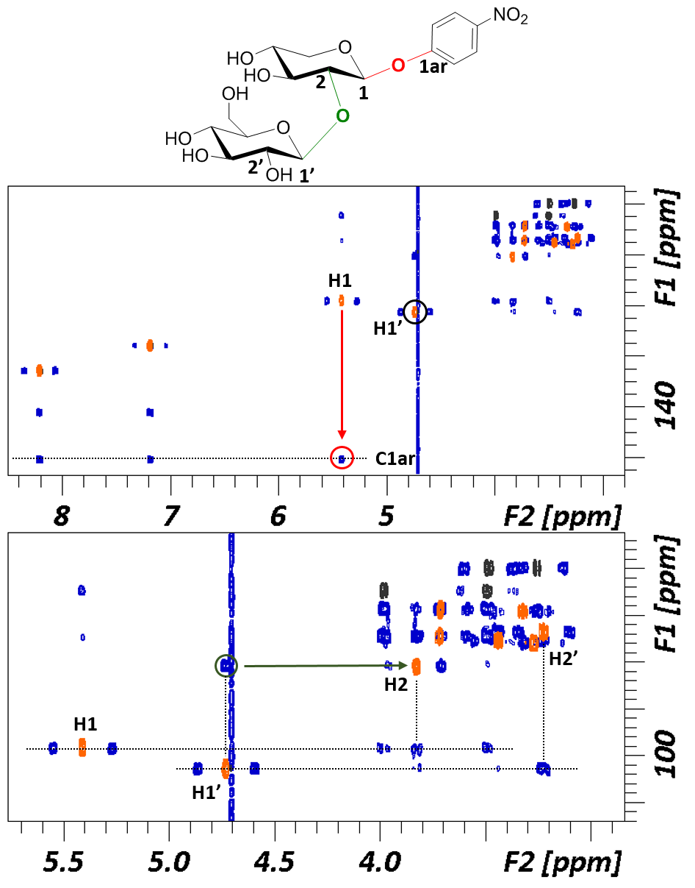
A

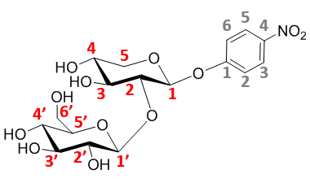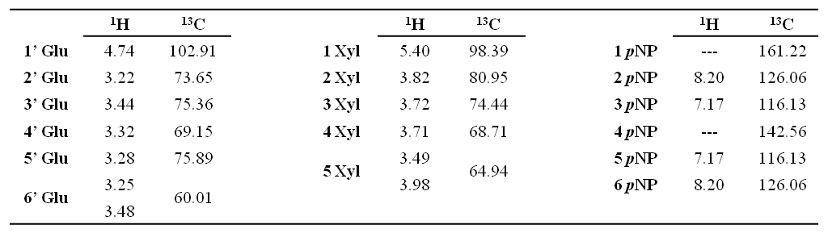
B

Figure S8. A) Top: structure of the Glucose-Xylose-pNP derivative. Superimposition of ¹H-¹³C HSQC (orange/black) and HMBC (blue). Bottom: Expansion of the carbohydrate region. Arrows represent the key cross peaks for the characterization of the molecule. The lower panel shows the correlation of the anomeric H1’ proton of the transferred glucose with the carbon at position 2 in the acceptor xylose for the disaccharide linkage (green), and the upper panel displays the correlation of the anomeric position of the acceptor xylose and the quaternary carbon of the pNP ring residue (red). B) Structure, deduced from NMR analysis, of the pNPX-glucose product obtained by transglycosylation of pNPX with the synthase BGL-1-E521G. Every C atom in the molecule is numbered to clarify the identification of the signals. Chemical shifts (ppm) are indicated in the table.

